Emerging Leaders in the American Program (ELAP) – 2020 Application form for Undergraduate Program

In each section, you will see screenshots from ELAP website for your reference. Please make sure to select and type in each answer section highlighted in yellow.

- PROGRAM:
- Component (The length of the study and program.): ______

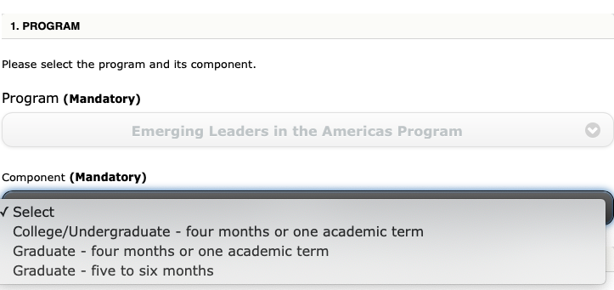

5. CONTACT PERSON RESPONSIBLE FOR THE PROGRAM AT CANDIDATE'S PROPOSED HOME INSTITUTION
- Salutation (Mandatory): ______
- First Name (Mandatory): ______
- Last Name (Mandatory): ______
- Job Title (Mandatory): ______
- Institution (Mandatory): ______
- Department/Office (Mandatory): ______
- Address (Mandatory): ______
- City (Mandatory): ______
- Province/State/Region: ______
- Postal Code/ZIP: ______
- Country (Mandatory): ______
- Email (Mandatory): ______

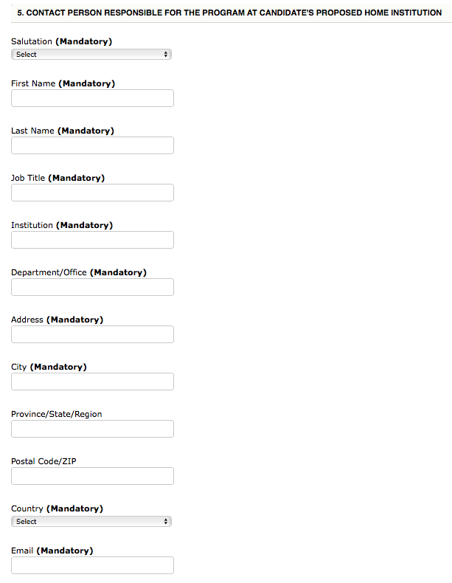

6. CANDIDATE INFORMATION
- Salutation (Mandatory): ______
- First Name (Mandatory): ______
- Last Name (Mandatory): ______
- Gender (Mandatory): ______
- Email (Mandatory): ______
- Country of Citizenship (Mandatory): ______
- Degree Sought at Home Institution (Mandatory): ______

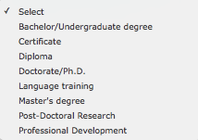
- Field of Study (Mandatory): ______


- Discipline (Mandatory): ______
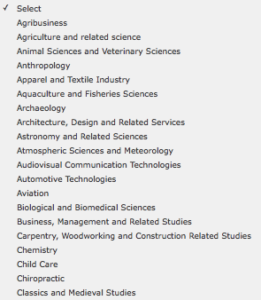
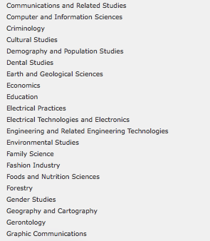
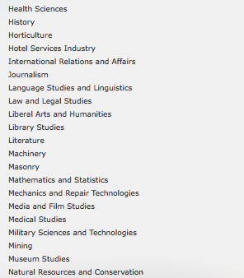
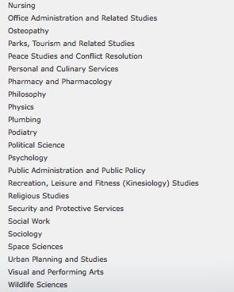

- Expected Completion Date of Degree (mm/yyyy) (Mandatory): ______

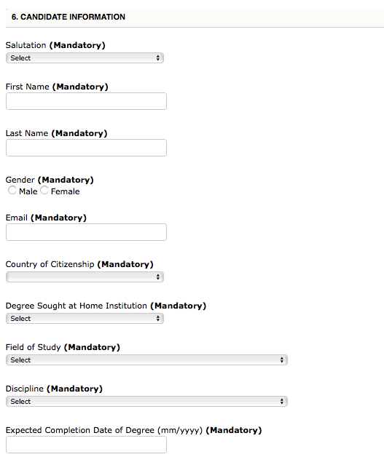

7. INTENDED SCHOLARSHIP STUDY/ RESEARCH:
- Provide a summary of the research project or a list of courses to be undertaken (maximum of 1000 characters). (Mandatory): ______
- Language of Study at Canadian Host Institution (Mandatory): ______
- Expected Start Date of Scholarship (dd/mm/yyyy) (Mandatory): ______
- Expected End Date of Scholarship (dd/mm/yyyy) (Mandatory): ______

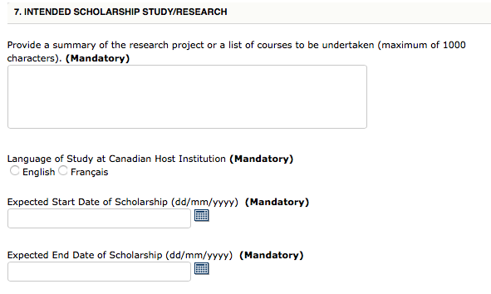

Supporting documents

The following documents must be uploaded and attached to the online application form in one of the following formats: .pdf, .jpg, .doc, .docx, .txt or .gif. Each document must be smaller than 5 MB in order for the application to upload successfully.

- Proof of citizenship: a copy of the candidate's passport or national identity document with valid dates and photo. Note: a driver's licence, permanent resident card, student card or baptism certificate is not accepted as proof of citizenship. The country of citizenship selected in the online application form must be the same as the country of the proof of citizenship.

- Proof of full-time enrolment: a letter in English or French from the home institution, on official letterhead, dated within the last six months, confirming that the candidate is currently enrolled in a full-time program and will continue to be enrolled upon their return and providing the expected completion date of the degree. Note: copies of transcripts, a student card or letter of admission are not acceptable (maximum one page).

The letter must clearly state:
- The type of program and the level of study of the candidate at the home institution;
- The full-time enrolment status at the home institution; and
- The anticipated completion date of the degree at the home institution.
Note: copies of transcripts, a student card or letter of admission are not acceptable (maximum one page).

- Letter of intent from the candidate: a letter in English or French from the candidate describing the nature of their research or studies to be undertaken and explaining the rationale for study in Canada and for the choice of institution, the program and the supervisor. The candidate must also indicate how the proposed program of study or research will relate to their future career (maximum one page).

- Letter of support from the home institution: a letter in English or French from the candidate's instructor, professor or international director on the institution's official letterhead explaining the nature of study and how the candidate and the home institution will benefit from this scholarship program (maximum one page).

- Letter of invitation from the Canadian supervisor (Graduate Studies Application Only): applications for graduate students must include a letter from the Canadian supervisor indicating their willingness to support and mentor the candidate. This letter must be on institutional letterhead, be in English or in French, be signed and demonstrate the support for the candidate during the exchange period and demonstrate how the Canadian institution, supervisor and peers will benefit (maximum one page).

- Signed copy of Memorandum of Understanding or Agreement with the partner institution: a written agreement or understanding, in English or in French, signed by both institutions indicating that tuition fees will not be charged and containing any other clauses of mutual interest. The specific clause in which the tuition fees are waived must be indicated. Note: a signed copy of this document is mandatory for undergraduate and college applications. For graduate applications, if the exchange is made under a signed agreement, it is strongly suggested that it be included with the application.

- Student’s transcript

- A list of Lakehead’s 3-4 courses student is interested in taking. When looking for courses to take, students can reference our academic calendar from our current 2019/2020 academic year. The courses for the 2020/2021 academic year will not be available until approximately June, however most courses will still be available, and it will give them an idea of what is available to them for study. HERE is the link to our academic calendar, http://csdc.lakeheadu.ca/Catalog/ViewCatalog.aspx?pageid=viewcatalog&cataloggroupid=25&catalogid=25&topicgroupid=23173&loaduseredits=true. The student will need to choose the program they are interested in (example: Business), and then it will list the courses available. Please note that these courses can be changed.

- Attached Privacy Notice Statement: a copy of the Privacy Notice Statement for non-Canadian participants dated and signed by the candidate (this PDF form is also included in the package).

Checklist

Please submit all the following documents including this checklist for successful application.

Supporting Documents |  | Check
1 | Completed ELAP 2020 Application form for Undergraduate Program
2 | Proof of citizenship
3 | Proof of full-time enrolment
4 | Letter of intent from the candidate
5 | Letter of support from the home institution
6 | Signed copy of Memorandum of Understanding or Agreement
7 | Students transcript
8 | A list of Lakehead’s 3-4 courses student is interested in taking  Please list here.
9 | Dated & Signed Privacy Notice Statement (included in the package)
10 | Checklist (all the boxes should be checked off)

